The design process1 is outlined next. The steps may be listed as follows:

Step 1 *Problem analysis.* The purpose of this problem, and how to implement this problem.

To plot the trajectory of the Fight path. Math: 牛頓運動定律。

Step 2 *Problem statement.* Develop a detailed statement of the mathematical problem to be solved with a computer program. See text p. 87.

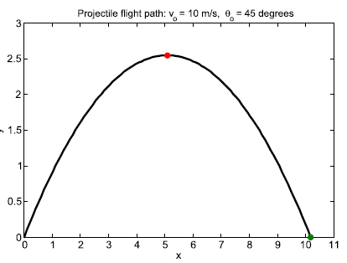

Step 3 *Processing scheme.* Define the inputs required and the outputs to be produced

by the program.

Step 4 *Algorithm.* Design the step-by-step procedure in a *top-down* process that

decomposes the overall problem into subordinate problems. The subtasks

to solve the latter are refined by designing an itemized list of steps to be

programmed. This list of tasks is the *structure plan* and is written in *pseudocode*

The goal is a plan that is understandable and easily translated into a computer language.

%% 8 steps of the projectile program in p. 89.

Step 5 *Program algorithm.* Translate or convert the algorithm into a computer

language (e.g., MATLAB) and debug the syntax errors until the tool executes

successfully.

Step 6 *Evaluation the result of your program.* Test all of the options and conduct a validation study of

the program.

Step 7 *Application.* Solve the problems the program was designed to solve. If

the program is well designed and useful, it can be saved in your working

directory (i.e., in your user-developed toolbox) for future use.